CS 401 - Software Engineering

Project Title: StudyLink

Group 4

Team Members:
Daniel Gray - Backend & database schema, APIs, authentication
Isabella Flowers - Project management, QA testing, documentation, UX flow
Ipreye Egbe - Frontend development with React Native, navigation, UI design

Date of Submission: December 1, 2025

What Is StudyLink?
StudyLink is a way to enhance and promote collaborative learning in the most accessible way possible. As we know, it can sometimes be a challenge to connect with peers who are also eager to study, share ideas, and build a deeper understanding of a subject together. In today's digital learning environment, technology plays a huge role in enhancing collaboration and supporting how students can learn. We often find ourselves doomscrolling and searching for ways to study more effectively on our own, even though learning by ourselves can be more challenging; sometimes, what we truly need is to engage and connect with others. Collaborative learning allows students to share different perspectives, helping each person better understand complex topics by seeing how others approach them. Through apps like StudyLink, communication becomes easier, allowing technology to be a connector, with an interactive experience, making learning fun once again.
StudyLink is a mobile application within the Education Technology domain that helps students create or join study groups based on their courses, topics, or location. It allows users to search and filter groups easily, receive notifications, and stay connected with peers. The goal of StudyLink is to provide a simple, reliable, and user-friendly platform that encourages collaboration and improves academic success.

Project Progress Layers
So far, we have completed Layer 1 (Functional Minimum) and are currently working through Layer 3 (Desirable Target). The app can now run on Android using Expo, connect to Firebase, and allows users to sign up, log in, and log out. Once they are logged in, the app shows a basic welcome screen showing the user’s email, showing that the backend connection and authentication system are functional.
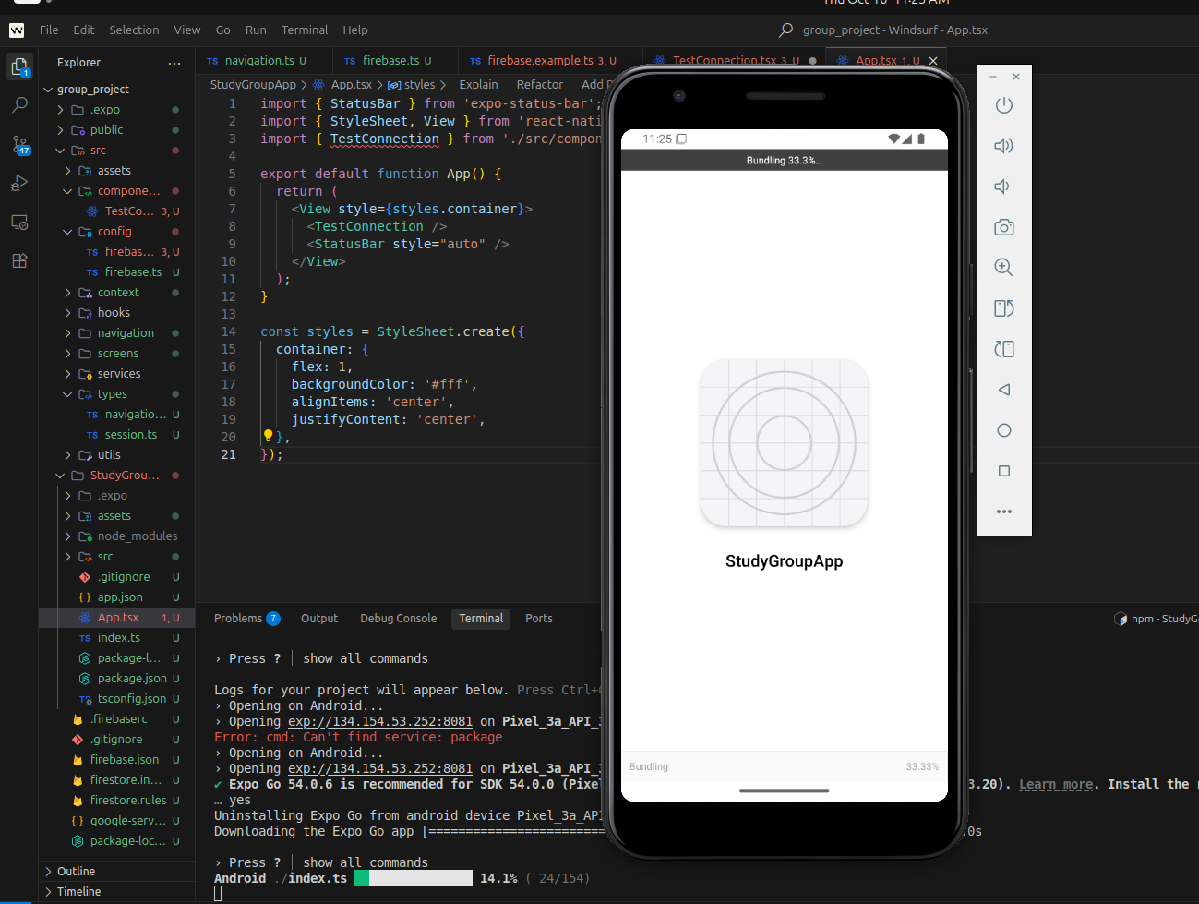

In Layer 2, we have a navigation between screens and started building a simple profile screen for users. We also connected the app to Firestore so that data can be saved and used later when we add features like creating or joining study groups.
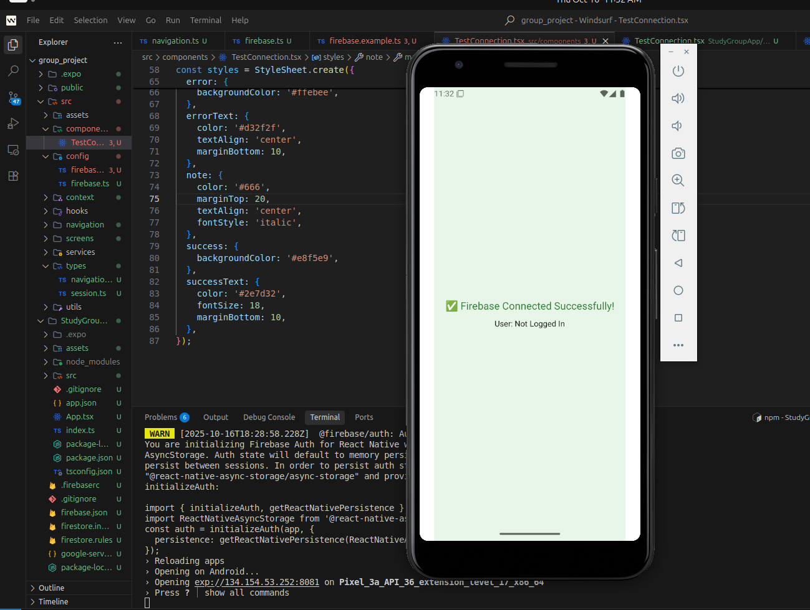
For Layer 3, we connected the Google Maps API so that users can view a map of study-group locations. The map can load properly and shows real locations, which moves us closer to our goal of letting users find study groups based on their city or area.
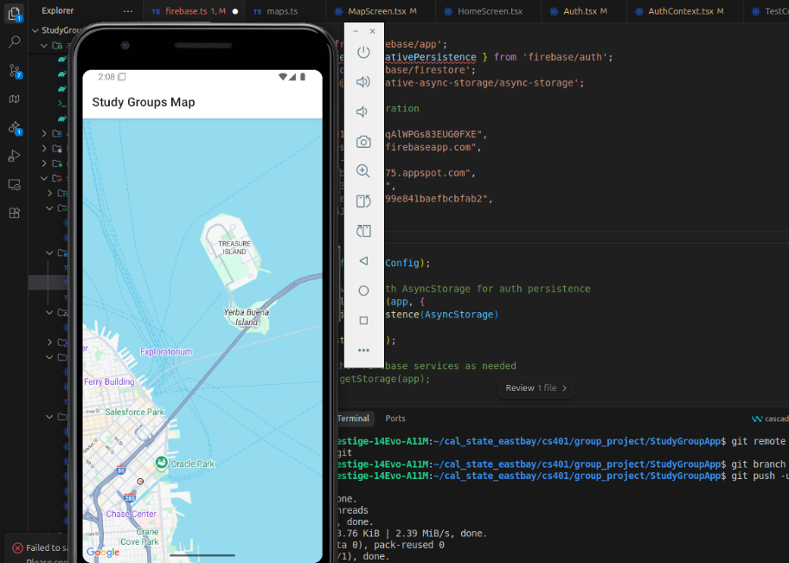

When users log in, they are greeted by a welcome screen showing their account email.
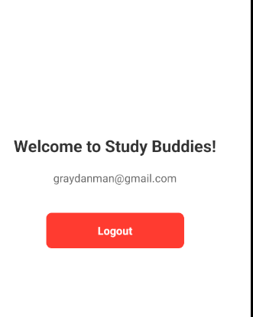

Summary:

Harder than expected:
Setting up and connecting Firebase with our React Native project was one of our harder challenges. Getting authentication, database access, and configurations to work easily took a lot of trial and error. We also had to learn how to manage app permissions, API keys, and emulator settings. The Google Maps API integration was another area that was challenging. Making the map display correctly inside the mobile interface and getting the location data to load the right way took more testing than anticipated. Another challenge was making sure that the app’s data model would be reliable for future features. We had to spend a decent amount of time thinking about how to store information from users, study groups, and locations so that the data would stay organized and easy to update.

Easier than expected:
After getting Firebase connected, building the login, signup, and logout features went smoother than expected. React Native’s tools and Firebase Authentication worked pretty smoothly together once we configured it properly. Creating simple screens, adding navigation, and styling the basic layout also became easier with practice. The hot reload feature in Expo actually helped a lot, allowing us to make some design changes and see results without restarting the whole app.

Design revisions:
When we tested different features, we made some small design changes to improve the usability. We simplified the layout to make it easier to read on smaller screens, and changed around the navigation flow so that the users could move between screens more smoothly.

Implementation challenges:
Some of the implementation challenges we ran into were some dependency conflicts between packages, and unfamiliar error messages that required researching and testing different solutions. Debugging Firebase connections and fixing layout alignment across different devices were also a little time consuming at times but we learned a lot.

